Tremor Reducing Smart Glove

A dissertation submitted in partial fulfilment
of the requirements for the degree
of

Bachelor of Engineering (Hons)
at
The University of Waikato

by

Akhil Babu
Supervised by:
Harish Devaraj



2021

2021

Table of Contents
Table of Contents 2
List of Figures 4
List of Tables 5
1 Abstract 6
2 Introduction 7
3 Literature Review 8
3.1 The Problem/Scope 8
3.2 Classification of Hand Tremors 8
3.3 Tremors Syndromes & Differentiation 9
3.4 Aetiology of Essential Tremors 11
3.5 Aetiology of Parkinsonian Tremors 11
4 Existing Treatments 11
4.1 Botulinum Toxin 11
4.2 Beta-Blocker Therapy 12
4.3 Deep Brain Stimulation 13
5 Potential Non-Invasive Solutions 14
5.1 Damper Glove for Hand Tremors 14
5.2 Gyroscopic Tremor Stabilisation Method 16
5.3 Mechanical Vibration to Reduce ET 17
5.4 Shape Memory Alloys (SMAs) 18
5.5 Shape Memory Polymers 19
5.6 Shear-Thinning Liquids 20
6 IMU data Processing and Neural Networks 21
6.1 Identifying hand movements using IMU Sensors 21
6.2 De-noising data using Wavelet Transform 22
7 Development 23
7.1 Phase 1 24
7.1.1 Experimental Setup 24
7.1.2 Post Processing and Identification 26
7.2 Phase 2 31
7.2.1 Addition of an MLP Network 31
7.2.2 NN Learning Optimization and Verification 34
7.3 Phase 3 37
7.3.1 Physical Design Concepts 37
7.3.2 Hardware and Electronics 40
8 Future Developments & Reflection 41
8.1 Software 41
8.2 Physical Design 41
8.3 Safety 42
9 Conclusion 43
10 References 44
11 Appendix 46
11.1 MLP Code Output 46

List of Figures
Figure 1: Block diagram of MuSe kit (7) 10
Figure 2: Log base 10 of tremors amplitudes as a function of tremor frequency (7) 10
Figure 3: Location of DBS target areas and substantia nigra (SN) (2) 13
Figure 4: Arrows denote the direction of magnetic field and the dot and cross correspond to direction (17). 15
Figure 5: Shows the theoretical peak readings against the ideal case scenario (17). 15
Figure 6: Gyroscopic stability of hand (18). 16
Figure 7: Experimental setup, task, and protocol (19). 17
Figure 8: Summary of changes in Tremor amplitudes (19). 17
Figure 9: Plot of Resistance vs Temperature for Nitinol (23). 19
Figure 10: Experimental setup to test effect of vibration on shear thinning fluid (29). 20
Figure 11: 3D Number set used by participants (31). 21
Figure 12: Recognition performance of proposed algorithm compared to others (31). 21
Figure 13: Heel Strike event more defined after denoising (32). 22
Figure 14: Experimental Setup to simulate tremors 24
Figure 15: Simplified diagram of experimental setup 26
Figure 16: IMU data retrieved from experimental rig 26
Figure 17: DFT output without half sampling 27
Figure 18:Half sampled data (left), the prevalent frequency (right) 28
Figure 19:DFT code time taken 28
Figure 20: FFT code time taken 29
Figure 21:FFT output showing prevalent frequency 29
Figure 22:Code flow of DFT Code 30
Figure 23: Code flow of FFT algorithm 30
Figure 24:Typical model of a MLP Network 32
Figure 25: NiTech MLP model for phase 2 32
Figure 26: Test result after training NN 33
Figure 27:Testing NN prediction on hand 33
Figure 28: Final Code flow of NiTech Tremor Classification program 34
Figure 29: Graph of Accuracy and Loss at each training epoch 35
Figure 30: Visualization of bias distributions for layer 1 36
Figure 31: Visualization of bias distributions for layer 2 36
Figure 32:Concept one involves nitinol in a spring form 38
Figure 33: Concept 2 with straight wires across 38
Figure 34:Concept 3 - NiTech Cage 39
Figure 35:Component placements 40
Figure 36: Final Prototype of the Design 43

List of Tables
Table 1: Classification of tremors according to moment of occurrence Error! Bookmark not defined.
Table 2: Table showing the effects with and without damping. Error! Bookmark not defined.

Abstract
In this review few of the main diseases that produce tremors will be looked at. The etiology of each disease will be researched. We also explored all the current solutions there were for treating diseases such as Parkinson’s Disease and Essential Tremor Disease. All the existing solutions were found to be rather invasive and as such noninvasive methods were looked for instead to find the best possible solution for the smart glove. Finally deciding on using nitinol as the main actuator for the smart glove.

A system to identify tremors was developed using a Fast Fourier Transform and Multilayer Perceptron Network (MLP). This system takes Euler angle at on axis, feeds it through an FFT and then feeds the resulting Frequency spectrum into a MLP network. The training data was obtained experimentally by simulating tremors between 2.3-6Hz using a designed oscillator. If the frequency spectrum correlated with the data from the training dataset, a tremor was said to be occurring. This method proved effective with an accuracy of 99.6%. The neural network was visualized through TensorFlow’s Tensorbaord tool in order to understand and verify whether the network was learning in the expected manner. By looking at accuracy and loss values at each epoch step, it was found that the distributions of biases moved away from 0 after each epoch indicating that learning was happening. It was noted that further improvements in training time could be made by increasing number of neurons in hidden layers 2 and 3.

In terms of physical design, the final concept involved the use a design called a “NiTech Cage” which consisted of two 3d printed braces with the nitinol wires weaved parallel between them. A thermal resistant glove will then be clasped inside the cage to provide insulation from the live wires and the heated nitinol wires. To ensure safety and comfort the temperature of the glove will be regulated at a comfortable temperature to ensure it doesn’t heat up to unsafe temperatures. This will be done through closed loop control using a thermocouple. The activation of the nitinol will also fail to occur if the thermocouple malfunctions to ensure the power to wire is not provided if regulation is not possible. Finally existing solutions for active cooling in order to combat thermal hysteresis of the nitinol proved to be bulky or loud, which results in a lesser comfort for users in day-to-day life, thus active cooling was avoided until better solutions in the future arise that provided better portability and a smaller form factor. The Final Design of this project requires more time and cost to make, as such the final prototype achieved this year aimed to show proof of concept of the idea and it is believed that was achieved.

Introduction
This Project aims to research and develop a wearable smart solution that helps in the mitigation/stabilization of hand tremors using methods such as SME (Shape Memory Effects) or other non-intrusive solutions that can be used for day-to-day operation. As a result, a smart, wearable tech is expected to be designed and developed based on the research. One that is non-intrusive yet allows individuals that require higher stability of the hand to achieve mentioned outcome. Whether that be Parkinsonian patients or other tremor inducing illnesses or patients helping patients carry out normal activities that would otherwise be difficult due to degrading motor control of the hand.

In this research project the students attempt to develop a smart glove that can mitigate tremors caused due to Parkinsonian and Essential Tremors. In this report the basic structure will be explored on how to tackle this problem. Current existing solutions will be explored along with invasive surgeries and medication.

From these observations a design will be made that focuses on developing a system to identify tremors, and a non-invasive actuation method in order to mitigate said tremors. Using tools such as Fast Fourier Transforms, and Neural Networks allow us to extract key features from simple IMU data to infer whether a tremor is happening. As such by the end of this report, the goal is to provide enough evidence of the possibility of developing a smart glove that can do such things, and providing a prototype that shows the proof of concept for this system.

Literature Review

The Problem/Scope
Hand tremors are a common symptom in many ailments that a human body can inhibit, with illnesses such as Parkinson’s Disease and Essentials Tremor disorder being some key examples. A hand tremor is an oscillatory movement in the hand which can lead to a decreased range of mobility and lessened dexterity. Hand tremors have a big impact on an individual’s life as suddenly tasks which seem menial at first, greatly increase in difficulty due to the lack of control of the hand. This disability along with factors such as depression, postural instability and cognitive impairment all contribute to a degraded quality of life (1). Thus, it is the goal of this project to reduce effect of one aspect of the many that can affect the quality of life of a patient dealing with symptoms of hand tremors. In this Literature review the etiology of two main tremor causing diseases, Parkinson’s Disease and Essential Tremor Disorder, will be researched along with the current solutions/treatments and different potential approaches to ensuring the decrease of the effects hand tremors can have. (2)

Classification of Hand Tremors
It can be understood that a tremor can be classified as involuntary, rhythmic, and sinusoidal alternating movements of any part of the body (3). It is said that a rhythmic oscillation is key to identifying a hand tremor, along with other factors such as change in amplitude that occur randomly. However, it is seen that the general frequency of the tremor itself remains fixed (4). This is a key knowledge for the project as it can allow in the identification of tremors and also assist in predicting and mitigating tremors using the smart glove more easily. Tremors can be classified in several ways, one such way being by looking at the moment of occurrence of a tremor. Resting tremors occurs when the body part in question is not actively moving and the effects of gravity are not prevalent. Several other classifications for tremors can be seen in the Table (1).
Table 1: Classification of tremors according to moment of occurrence (3).
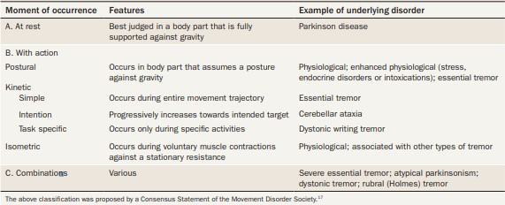
In this table it is seen that tremors at rest are associated with symptoms of Parkinson’s Disease. We also see that tremors that occur during active movement (Kinetic Simple Tremor) can be attributed to Essential tremors along with Postural Tremors that occur when a body part is held against gravity (3)

Tremors Syndromes & Differentiation
Essential tremors are found to be one of the most common tremor disorders, usually affecting the arm (5) region. The frequency of the tremor is mostly found to be between 4-12Hz, and as stated before is seen to be an action tremor. Comparing this to a Parkinsonian Tremor, we see that the frequency of the tremor is found to be 2.5-6.8Hz (6)which is much lower than the ET frequency. This change in frequencies can be help the Smart Glove differentiate between the two different ailments. Parkinsonian Tremors are usually found to occur in the asymmetric upper limbs, legs, and jaw (5).

To differentiate between the two tremor types, a pilot study was done using a miniaturised multi-sensor platform, called MuSe that contained several high accuracy IMU components along with a microcontroller and a 3D Geomagnetic system (7)

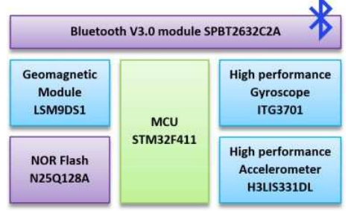
Figure 1: Block diagram of MuSe kit (7)

The 27 (in which 16 had Parkinson’s Disease and 11 had ET) patients in the study were then asked to run a series of 4 tasks. The tasks went in the order of, resting their hands, holding their arm in the air parallel to the ground, extending their wrists and slowly drawing a spiral on the sheet. This was to highlight a specific tremor at each task. What was found according to the study was that there was a clear difference that could be noticed between both Parkinsonian tremors and Essential Tremors (7).

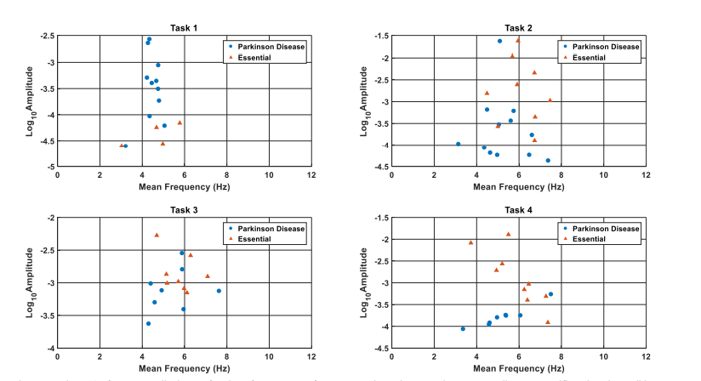
Figure 2: Log base 10 of tremors amplitudes as a function of tremor frequency (7)
As can be seen in Figure (2) there was a clear difference in amplitudes between different tasks. While resting (Task 1) Parkinsonian Tremors showed higher amplitudes while during the kinetic and postural tasks such as Task 2 and 4 the amplitude of essential tremors was higher. This allows us to conclude that it is possible to differentiate between both Parkinsonian Tremors and Essential tremors using low-cost Gyroscopes and Accelerometers (7).

Aetiology of Essential Tremors
It is found that Essential Tremors are hereditary and the evidence of such was found in several genes. Along with that it was found that no structural or physical changes were found in the brain for patients with Essential tremors. One suggestion is that ET is caused by a disturbance that is occurring in the olivocerebellar circuit (8). In the case of how one gets ET in their life is dependent on factor such as your genetics, however a study has found that environmental factors may play just as much of a role (9).

Aetiology of Parkinsonian Tremors
If the classic Parkinsonian tremor is considered here, meaning tremors that are caused at rest, one of the typical signs for Parkinson’s disease is a degeneration of the dopaminergic cells within the substantia nigra along with a depletion of striatum. The general agreed upon theory used to be that the Parkinsonian tremor is generated within the basal ganglia loop however there is much debate with several hypothesis stating that the tremors indeed originate from the cerebellothalamic loop. However, the current census remains to be the Basal Ganglia Loop (8). It is also found out that PD is most likely to be obtained from the combined effects of your genetics and other environmental factors that have still yet to be identified, yet just like ET it seems the predominant factor is your environment (10).

Existing Treatments

Botulinum Toxin
One method of mitigating the effects of hand tremors is to use Botulinum Toxin (Botox). In an initial pilot study, it was found that 67% of head-neck and hand patients saw a medium to good functional improvement and a decrease in the effects of tremors. Several other experiments were conducted using Botox and all showed signs of improvement with the peak effect taking place at 16 weeks. The side effects that were caused however were seen to be weakness of the hand , decreased grip strength. The side effects seemed to effect 30% of the low dose population and 70% of the high dose population (11). Other side effects were also noted such as rashes, pain, stiffness cramping, hematoma, and paraesthesia.

The key to ensuring that side effects are not as prevalent, and the dosage is most effective is to accurately locate the target muscles and apply the right injection technique as opposed to a fixed-muscle-fixed dose approach. This involves examining the tremor in different positions with the hand at rest, choosing which muscles need to be individualised, adjusting the dosage depending on the response to tremors and avoiding extensor muscles (12). To select the target muscle several techniques can be used such as manual exam, accelerometery, ultrasound etc. In summary the results show that Botox works to a certain degree, but it contains side effects that not all patients would be willing to risk.

Beta-Blocker Therapy
A study was run to test and review the efficacy of beta-blockers in treating Parkinson’s Disease. A trial test was done where beta-blocker therapy and a placebo were tested on 72 patients (13). Beta-Blockers, which were first used in the 1960’s to treat hypertension, are a group of drugs that block the action of endogenous catecholamines on beta-adrenergic receptors (14). In general terms, they can attenuate or block the hormones associated with emotional or physical stress from being received by the beta-adrenergic receptors. This property exhibited by beta-blockers is also applied to treat other disease where stress can have negative effects on health or quality of life. As such since Parkinsonian tremors tend to increase under stress, beta-blockers have been used to attenuate the signs of tremors.

In the randomised study patients (Diagnosed with Idiopathic Parkinson’s Disease) were either given adjuvant oral beta-blockers (depending on the study either oxprenolol or propranolol) or a placebo. The outcome of the study was measured by looking at the factors (13):
- Quality of life assessment
- Parkinson’s disease activities and motor scale ratings
- Individual motor performance
- Accelerometer readings
- EMG Activity
- Patient Self-evaluations
- Blood pressure changes
- Number of Withdrawals
Moving forward a few of the outcomes measured in the study can be used for the Smart glove project to determine the effect of the glove for example, Accelerometer readings, Quality of life Ratings and Individual Motor performance. Unfortunately, from the study referenced, the results for the efficacy of beta-blockers for treating tremors was found to be inconclusive to lack of evidence. A result was noted however that saw a high frequency of decreased heart rates for patients in one trial, which in turn raised concerns of the side effects involved with beta-blockers (13). It is for this reason that the Smart glove can be seen to have advantage due to its non-invasive approach.

Deep Brain Stimulation
Another effective, invasive method for treating several neurological conditions including Parkinson’s disease is Deep Brain stimulation. DBS involves surgically implanting the lead which consists of 4 electrical contacts into the target region of the brain. Secondly a device called an implantable pulse generator (IPG) is implanted under the collarbone, after which the lead is connected to the IPG. An IPG is responsible for generating the pulse widths that will then be applied by the lead to the area of effect to provide a continuous electrical stimulation to the target neural structure (15). The DBS system is fully versatile as it allows the patient or clinician to have very precises control of specific parts of the brain that need to be stimulated. To treat Parkinson’s disease, the DBS lead is usually placed withing areas of the brain labelled GPi (globus pallidus internus) and the STN (subthalamic nucleus) as these areas tend to have an important role in sending the signals for motor control. As such by providing an electrical stimulus to these areas, an individual’s motor control can become more fluid (15).

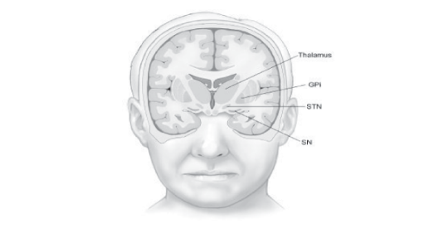
Figure 3: Location of DBS target areas and substantia nigra (SN) (2)
In some instances, it is also beneficial to place a DBS lead near the ventralis intermediate nucleus (VIN), especially to treat arm tremors. To attenuate ET symptoms, it was found out that the best target area to implant the DBS lead was near the VIN with an average tremor reduction of 80% (2).

Despite DBS treatment showing good promise it was found that due to the high-risk nature of neurosurgery, there are several complications that can occur during and after a surgery. A study looked at the complications associated with DBS treatment and classified the complications into 3 categories:
- Operation-related
- Hardware-related
- Stimulation-related
After looking at all DBS surgeries from 1997-2008 (100 DBS electrodes inserted in 55 patients) it was found that there was one case of a symptomatic cerebral haemorrhage and two cases of electrode malposition. Two hardware issues of fractured electrode were also discovered along with several other complications (16). As such despite the benefits of DBS treatment it has a very high-risk factor and is an invasive method.

Potential Non-Invasive Solutions

Damper Glove for Hand Tremors
A potential solution that was found was a Damper glove that would be able to assist people patients dealing with hand tremors by using a damping system that utilised dampers and electromagnetics. A lightweight and portable damper system is designed using two electromagnetic coils and a magnetic weight (17). Solenoid were also designed to have the same magnetic field as the mass damper using amperes law:
$$B=\frac{μNI}{L}$$

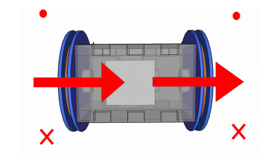
Figure 4: Arrows denote the direction of magnetic field and the dot and cross correspond to direction (17).

A Adafruit 6DOF Inertial measurement unit (MPU6050) is used along with an Arduino Uno as a microcontroller. Using the IMU values the values are then interpreted using Euler angles, with the IMU components having a time lag of 15ms due to hardware limitations. An estimation of the tremor response is done using an ideal case actuation.

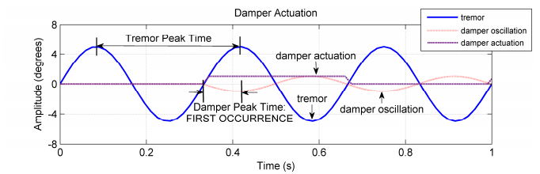
Figure 5: Shows the theoretical peak readings against the ideal case scenario (17).

From the data we see that the damper oscillation does indeed time properly with the tremors which will ultimately result in a decrease in tremor amplitude. However, since real life tremors are far from ideal the next phase involved running a test while wearing the glove and simulating the hand tremors. The actuation of the solenoid is constituted by setting limits on the values gained from the Euler angles. Where when the difference in angle is bigger than 2° the actuation will occur in the opposite direction to the rate of change.
Table 2: Table showing the effects with and without damping (17).
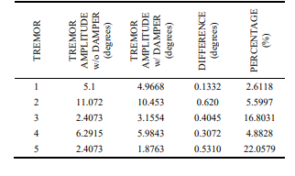
As can be seen from Table (3), the tremor amplitudes with without damping are consistently higher than tremor amplitudes with damping. From this it can be concluded that there is a decrease in tremor amplitudes (17).

Gyroscopic Tremor Stabilisation Method
The following design shows a patented idea that works on the principal of using a spinning gyroscope to stabilise the hand and ultimately mitigate hand tremors that may occur. Gyroscopes, when spinning have a natural tendency to resist any changes in angles. This design works by attaching wearing a glove that has a spinning gyroscope on the top part of your hand. As your hand starts to experience tremors, the stabilising nature of the gyroscope will naturally react and fight the change in orientation of the hand (18). This method however does not provide a minimal form factor and is quite bulky for everyday use.

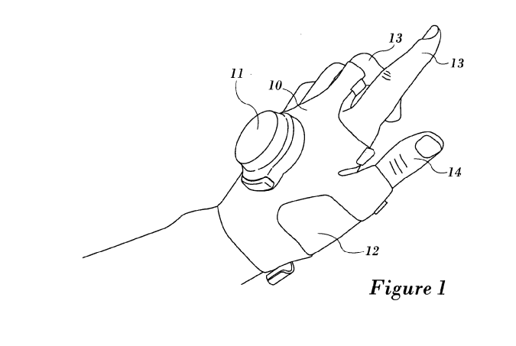
Figure 6: Gyroscopic stability of hand (18).

Mechanical Vibration to Reduce ET
One method that was considered in a study was the application of mechanical vibration to certain areas of the arm with the highest concentration of Pacinian corpuscles to modulate and decrease the effect of the said tremors. To do this, piezoelectric actuators were placed along the hand and arm of a patient diagnosed with ET and the whole arm was placed on an arm support in order add more control to the test. (19)
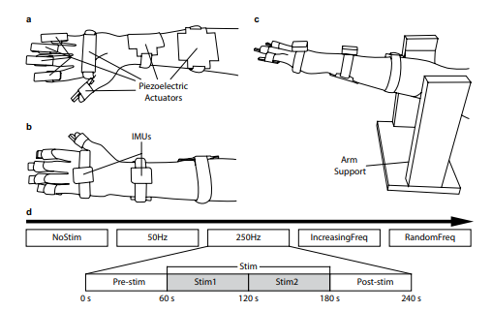
Figure 7: Experimental setup, task, and protocol (19).
5 different levels of stimulation were tested as can be seen from figure (7), Increasing frequency refers to a steady increase in frequency from 50-450hz in increments of 50hz, while random frequency employs any value between 50-450hz but in random order.

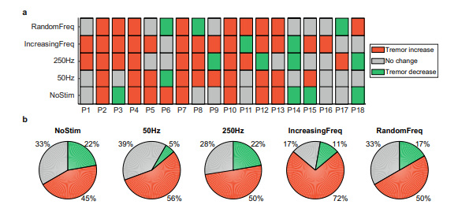
Figure 8: Summary of changes in Tremor amplitudes (19).
Looking at Figure (8) we see that as stimulation was applied, the tremor amplitude increased for a majority of the patients when compared to No Stim. The most in tremors happened during the increasing frequency, as such it can be concluded that applying a mechanical vibration to the Parisian corpuscles of the arm do not in fact reduce the effect of tremor and rather makes them worse.

Shape Memory Alloys (SMAs)
Shape memory alloys are materials that possess the unique characteristic of returning to a pre-programmed shape upon reaching a certain transformation temperature. One of the most common SMAs is Nitinol which is a Nickel and Titanium alloy that has characteristics such as super elasticity and shape memory effect. Shape memory essentially works by switching between two phases, Martensite and Austenite. At low temperatures, the alloy is in the martensite phase where the metal is free to be deformed and is malleable. When heat is applied up to the rated transformation temperature, the metal changes phases into the austenite crystalline structure (20). Nitinol is also considered to be super elastic; this is when a material provides an elastic response when a load is applied to said material (21). Such is a good reason why nitinol is used in braces to ensure a constant applied load to maintain teeth. This superelasticity attribute can also be useful for using with the smart glove as it will help provide a constant resistive force to tremors.

Nitinol can be bought in different grades, one such being NiTi-Cu which is a grade of nitinol with good electrical conductivity. When an electric current is passed through nitinol wire, through the effect of joule heating one is able to get the metal up to its transformation temperature (22). However, in order for the glove to be effective the transformation time between states has to be quicker. A study looked at increasing the speed of shape memory alloys through faster electrical heating (23). It is discussed that it is possible to increase speed by providing a sufficiently large current, however this runs the risk of permanently damaging the SMA.

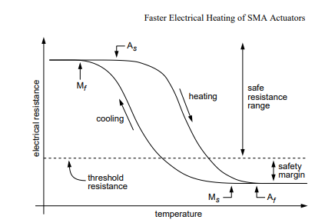
Figure 9: Plot of Resistance vs Temperature for Nitinol (23).
In order to achieve faster heating without damaging the SMA, the electrical resistance of your SMA must be measured, after which calculate the threshold resistance and ensure that your heating current does not go over the calculated threshold. According to the study this technique will double the transformation speed allowing for a quicker response to vibrations. Another factor that has to be considered with nitinol is functional fatigue under cyclic loading and use. According to one article researchers have noticed the decrease in Nitinols functional properties. It is seen that as the number of cycles of an SMA goes up, the hysteresis loop gets smaller (24) . In summary however nitinol is seen to be the best choice so far due to the fast response times and minimal form factor.

Shape Memory Polymers
Shape memory Polymers are materials that will change shape upon the arrival of an external stimulus. In the case of thermally induced SMPs a permanent shape is programmed by either heating up, deforming, and cooling the sample or the sample is cold drawn (25). After which if the polymer is heated up past its transformation temperature it goes back to its programmed shape. A group has also succeeded in making SMPs that are magnetically activated which allow for more freedom with shapes and allowing parts to manipulate their own shape. (26)

Another study showed the use of SMPs filled with conductive fillers in order to be triggered upon an electric stimulus. By using multi walled carbon nano tubes, a group were able to create electroactive SMPs (27). These SMPs would be a good alternative for the smart glove as using electricity as an activation method provides the best adaptability for design and comfort.

Shear-Thinning Liquids
Shear thinning fluid are a non-Newtonian fluid whose viscosity decreases when subjected to shear strain (28). In a study it was seen that by applying sinusoidal vibrations to a shear thinning liquid (CMC or PAA) in the longitudinal direction, the flow of said liquid would be increased and the apparent viscosity of the liquid would be low (29).

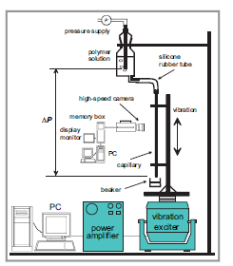
Figure 10: Experimental setup to test effect of vibration on shear thinning fluid (29).

The experiment setup up is a capillary tube connected to a bottle of CMC which is held still by a stand. A longitudinal vibration is applied to the capillary tube at frequencies of 5 to 40Hz and amplitude of 1.5 to 10mm. the mass flow rate is calculated by measuring the weight of the liquid caught in the beaker. In summary it was found that increasing the vibration amplitude also increased the overall flow rate of the CMC liquid in the tube. A similar experiment was also done by Deshpande et al, however they were able to prove that the shear thinning fluid lowered in apparent viscosity when a sinusoidal vibration was applied in the axial direction. (30).

IMU data Processing and Neural Networks

Identifying hand movements using IMU Sensors
A study was done which aimed to develop a hand gesture recognition (HRG) system that was able to handle time-dependent data that was provided from an inertial measurement unit (31). Most HRG systems do not attempt to mitigate the degradation that occurs during real time learning as such this paper proposed a system that used Dynamic Time Warping (DTW) and a Restricted Column energy (RCE) in combination. By doing so the algorithm has a better accuracy when it comes to recognizing time-dependent sensor data while at the same time making it more proficient in real-time learning (31).

In order to experimentally verify the algorithm, 5 participants were asked to write ten digits in the air while holding an IMU. The accelerometer values were taken at a sampling rate of 20hz, and the participants were asked to do this 20 times. In total 1000 hand gestures were retrieved.

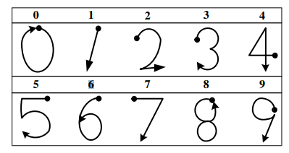
Figure 11: 3D Number set used by participants (31).

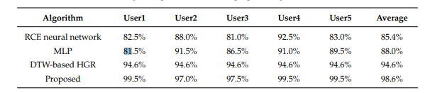
Figure 12: Recognition performance of proposed algorithm compared to others (31).
As can be seen in figure (12) the proposed algorithm showed better performance (data obtained through 5-fold cross-validation) than other compared algorithms and performed consistently well for each participant. This method can also be applied to the NiTech glove is it too uses time dependent IMU data to identify tremors and also learn in real time.

De-noising data using Wavelet Transform
One approach to de-noising signals and data is to apply the wavelet transform. More specifically, a study proposed to identify gait events using a single wireless IMU. In order to denoise the IMU data, wavelet denoising was used (32). Wavelet denoising allows for the cleaner data retrieval and identified significant changes within the data that could be categorized more clearly due to less noise. In the case of this study, Gait events were able to be identified better due to the enhancement of turning points in the data (32).

In order to record gait data an IMU is placed inside the sole of a shoe. A wavelet transform is then applied as a signal decomposition and an inverse discrete wavelet transform as a signal reconstruction method. In order to denoise the data, filters are used that either average the data or produce the details that are significant in the data. By then removing the average data which contains imitable values, and then calculating the inverse wavelet transform for reconstruction using the acquired wavelet coefficients. A cleaner more detailed signal is obtained which clearly shows the wanted significant effects.
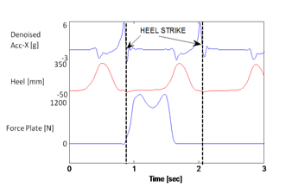
Figure 13: Heel Strike event more defined after denoising (32).
The result as can be seen in figure (13) is a more well-defined event which can then be used to accurately predict when an event occurred. This same principle can be used for the NiTech data to obtain a clearer defined data of the hand tremors using IMU data.

Development
The development of what is dubbed the “NiTech” glove, while at first look tends to be heavily focused on design, as the project continued on it was becoming more prevalent that the identification of tremors alone would also pose a great challenge. Tremors in the hand are a very complex non-linear problem (as can be seen by the “Van der Poll equation” (33) below) that poses several nuances and caveats when trying to gauge an accurate understanding of its dynamics.

$p''- µ(1 - {p }^{2} )p' 0 + p = 0$ (2)

As such a more specific and overall pattern had to be recognised that could be applied under any situation. More specifically a holistic and effective approach had to be taken in order to identify tremors before the design process even began. In the development phase the following points posed the biggest challenge:
- Implementing a system that could identify tremor while also being able to isolate tremors from everyday activities that could pose similar characteristics such as writing etc.
- Develop an actuation method that required little or no moving parts and had a minimal form factor.
- Develop a design that could accommodate all the necessary components needed while still being comfortable to use. The components used also had to be energy efficient and help the overall design achieve portability.
Off these challenges however, developing a system to accurately identify tremors took the majority of the time, as such the development of a final product was not achieved. However, solutions were found for the remaining challenges and showed great promise. These solutions will be explored later in the development section. As mentioned before also the main illness that was focused on out of the several tremor inducing illnesses was Parkinsonian and Essential Tremors, however this project is able to be applied to the other tremor illnesses as well with further development.

In order to meet these specifications within the timeframe and budget the problem was simplified using pattern recognition. Pattern recognition is the process of finding similarities between different scenarios and aiming to use said similarities as the target problem. In the case of this project that was found to be the tremor frequency that was present in tremors. This tremor frequency that was mentioned before in the Literature review section (2.5-6.8hz) was the main foundation on which the system was built, especially for phase 1 of development. Later on, however a more flexible system was put into place in phase 2 in order to provide a more accurate and effective way of gauging tremors, using neural networks

Phase 1

Experimental Setup
Due to reasons such as the global pandemic and ethical reasons, the help of an Essential Tremor patient could not be acquired. This meant that in order to accurately simulate effects of tremors that could then be analyzed for the project, an experimental system had to be designed that could effectively portray the target problem that we were attempting to mitigate while still maintaining a logical process on which to then test the actual identification system. Since the foundation of our project is the prevalent frequency present in tremors, a simple Rotary-to-Oscillatory machine was designed.

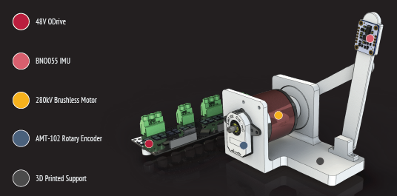
Figure 14: Experimental Setup to simulate tremors
The design shown in figure (11) is one that uses several components in order to best simulate the effects of tremors. The motion of the main member is restricted to one plane only, this is because for the purpose of tremor identification, as will be discussed later in the document, only one axis of rotation is looked at due to the frequency of a tremor remaining the same despite the changes in amplitude that can be faced due to movements in different axis of rotation. The main aspects of the design were produced using 3D Printed Parts with a layer height of 0.12mm for a smoother finish on all surfaces. An infill of 80% was also used with a wall thickness of 3mm to ensure that the whole system did not flex unnecessarily due to the inertia of the moving parts. All rotational contacts were fitted with bearings to ensure that no plastic-to-plastic interactions occurred, which may have resulted in extra noise when obtaining readings. The whole setup was also fixed onto a stable foundation to ensure that the whole rig did not move during use. Unfortunately, flex was still present in small amounts primarily at the mounts between the motor and the housing, however the effect this has on the output data is negligible.

In order to actuate the design a 280kV Brushless DC Motor was used. This is because brushless motors provide a smooth rotation along with the ability to vary the RPM more easily and with greater fidelity. With a brushless motor one also has the option to alter the amount of torque it has by adjusting the current fed to the motor resulting in options where the amount of torque a tremor can imbue can also be simulated as well (This feature however was not utilized as the purpose of the testing rig strayed from original requirements).

To Ensure that the motor was simulating tremors in the most effective way a 56V ODrive motor controller was used along with a CUI AMT102-V Capacitive encoder. By using the ODrive the rpm of the motor is able to be controlled resulting by using a Velocity feedback control. By doing this the oscillating member is able to be set to desired frequencies. The Rotary encoder has a CPR (counts per revolution) of 8192 as well which is well within the resolution needed for this experimental rig.

A problem that can occur in many BLDC motors is a phenomenon called “cogging”. Cogging is a torque ripple effect that occurs in low rpms where the rotation of the motor is not smooth, rather its staggered at some points. Cogging torque, occurs when the permanent magnets that are found on the rotor are attracted to the salient parts of the stator resulting in uneven rotation (34). This at high speeds is negligible as the inertia of the rotor overcomes the attraction. However, at lower speeds the risk of Cogging is high enough that it can have a negative effect on data. As such to ensure that cogging does not affect the validity of tremor simulation, an Anti-cogging algorithm was in the ODrive motor controller. This algorithm aims to mitigate the effects of cogging my mapping out all cogging points using measured voltages. By then, simplified terms, subtracting the voltage readings at cogging points a smoother rotation is achieved.

Finally in order to measure the oscillation and record the relevant data a BNO055 IMU is used. The IMU is programmed to calibrate before each test and the measured input is the change in Euler angles, more specifically, the change in Euler angle along the Y axis. The values for the Euler angle are then sent back into a Raspberry Pi 3B+ for further post processing and analyses.

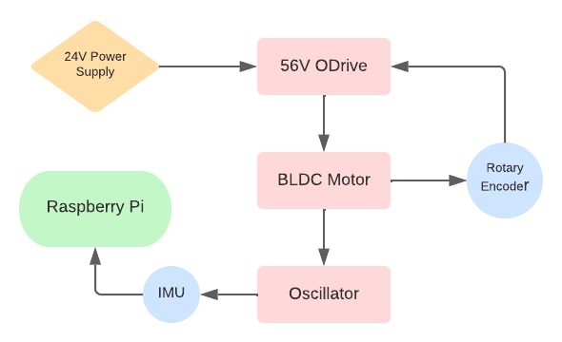
Figure 15: Simplified diagram of experimental setup

Post Processing and Identification
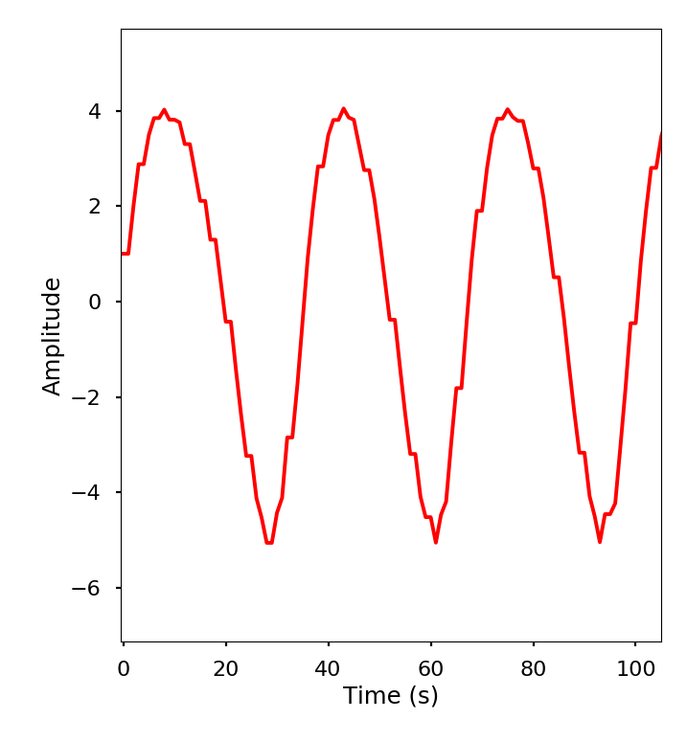
Figure 16: IMU data retrieved from experimental rig
Once the data from the IMU is transferred over into the RPi there are several methods that were thought of in order to classify between tremor and non-tremor data, the option that was chosen for this project was the decomposition of the data into its prevalent frequencies by using a Fourier transform. The programming language used for the majority of the project is python due to its extensive availability of libraries such as Numpy and Scipy.

To start off the data is recorded for exactly one second as an array and stored in a .CSV file after which it is then plotted in order to examine whether the resulting data matches the expected result of a sinusoidal wave as can be seen in figure (13). Once the data is cleaned up by removing NAN values and outliers using a low and high pass filter, it is then feed into a Discrete Fourier transform (DFT).

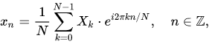
(3)
A DFT algorithm is able to take in finite amounts of data in the time domain and provides the values of amplitude in the frequency domain as a complex value X_{k}. By doing so one is able to observe the composition of sine and cos waves that make up a set of data.

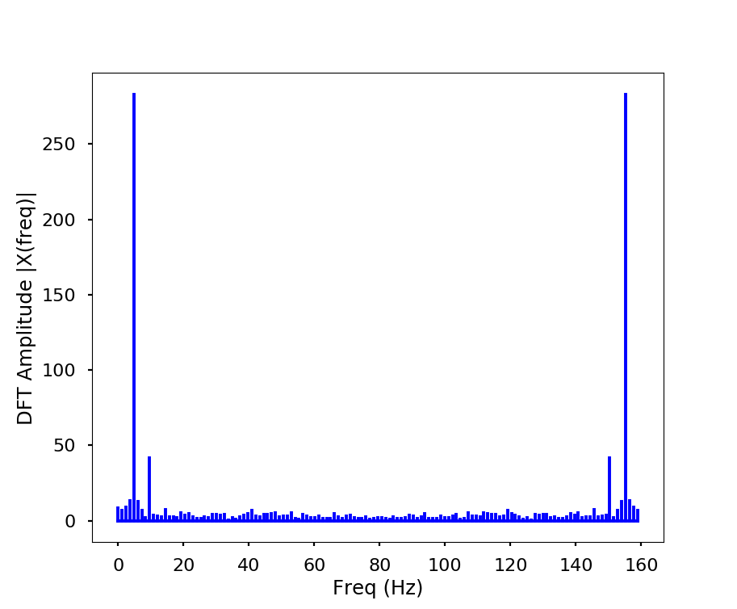
Figure 17: DFT output without half sampling

As can be seen in figure (14) the obtained shows the amplitudes along the frequency axis. However, when using DFT the resultant output data is symmetrical about half the sampling rate. As such the second half of the data needs to be removed in order to obtain the Nyquist frequency. Once that is done, we are able to what the most prevalent frequency is for a given set of data, as can be seen in figure (15) below.

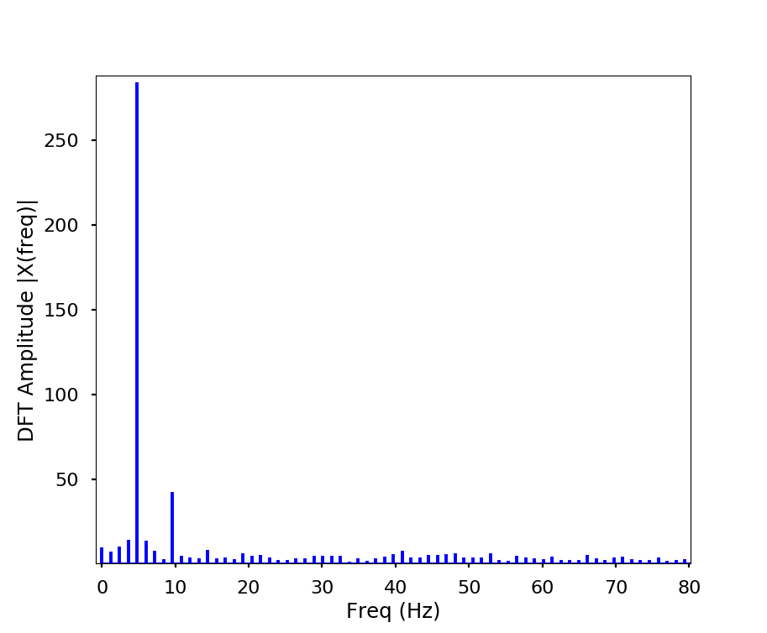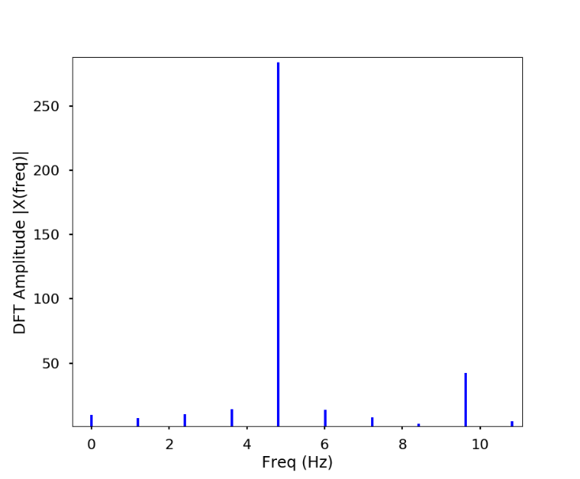
Figure 18:Half sampled data (left), the prevalent frequency (right)
When looking more closely on the right figure (15) we are able to see what the prevalent frequency is seen to be. In the case of this scenario the resultant prevalent frequency of approximately 4.8hz matched with the input we gave the motor to run at which was 5hz. There is still room for improvement however which was achieved using a more polished and efficient method of the Fourier transform which is called the Fast Fourier Transform (FFT).

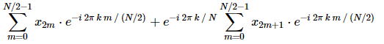
(4)
Unlike the DFT algorithm, FFT is seen to be significantly faster due to how the problem of a Fourier transform is approached.
Figure 19:DFT code time taken

By exploiting the symmetry in computations used in DFT the FFT algorithm aims to half the sample size into odd and even groups resulting in a faster computation time. Where DFT scales by O[N²], FFT on the other hand scales as O[NlogN], thus resulting in significantly less computation time.
Figure 20: FFT code time taken
This speed in computation is very valuable for this project as the components used will have very low processor speeds which may result in an output lag, which in turn can result in a delayed activation of the actuation system. Using FFT however also gives the same output when compared to DFT as such there is no trade off.

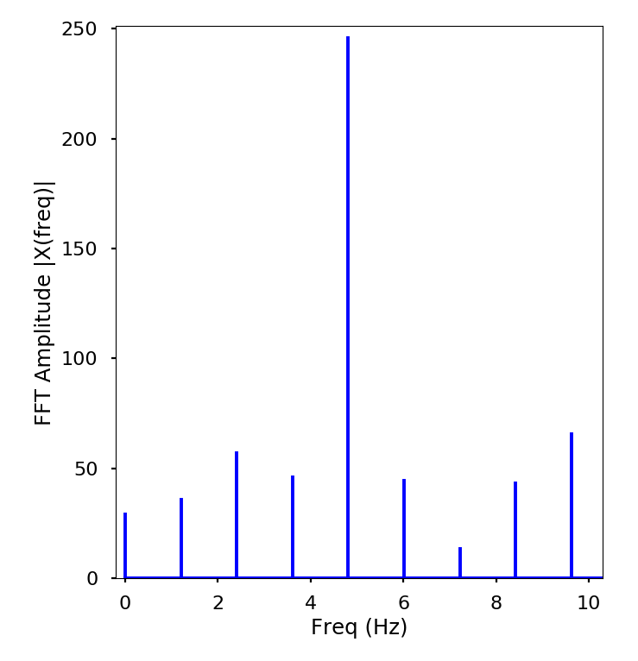
Figure 21:FFT output showing prevalent frequency

After the FFT is completed for each incoming dataset, it is then passed through an algorithm that determines the prevalent frequency by looking at each X_{k} value, finding the highest amplitude and as such the corresponding frequency. If the value of the frequency falls between the range of 2.5-6.8hz, it is classified as a Parkinsonian Tremor. In order to ensure that one outlier does not affect the activation of the nitinol wire a moving average of the prevailing frequency is implemented before classification.

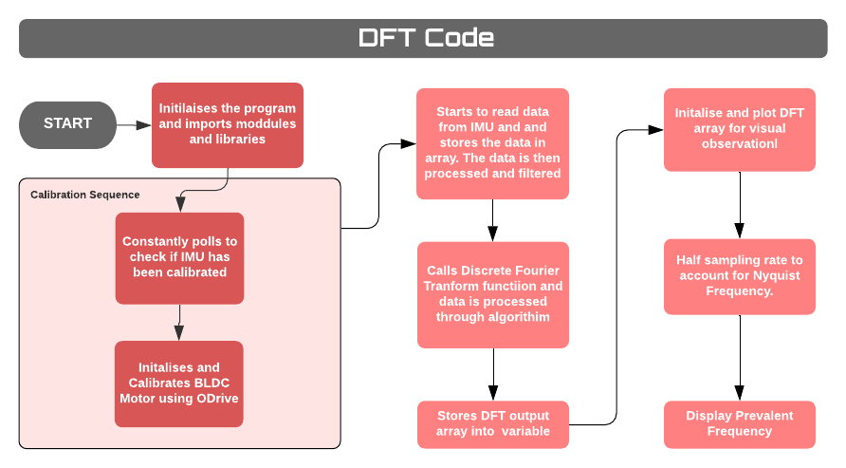
Figure 22:Code flow of DFT Code

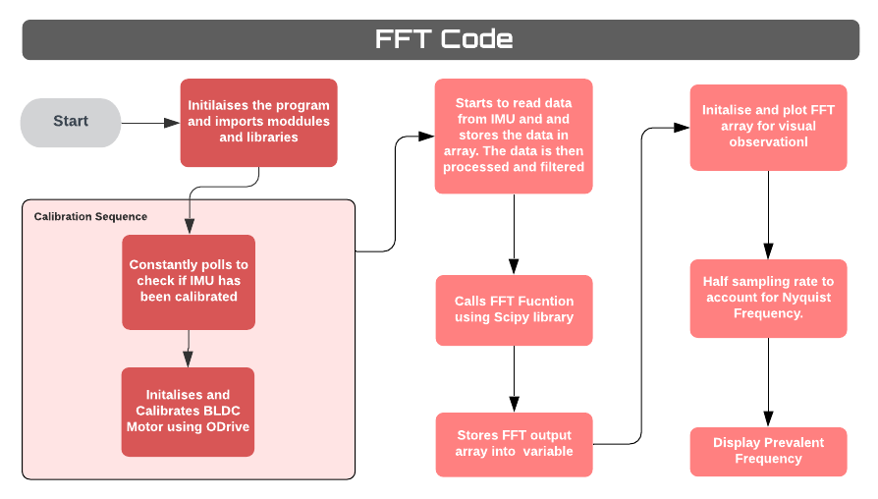
Figure 23: Code flow of FFT algorithm

Phase 2

Addition of an MLP Network
In phase 1 all data was acquired from the experimental setup that was used to simulate the effects of tremors under ideal conditions with minimal noise. However due to the nature of this project, use of the glove must be viable outside of the experimental setup. As such phase 2 had the goal of determining whether the same FFT system from phase 1 could be applied in a situation where the user is physically wearing the glove and experiencing tremors. Secondly phase 2 also had the goal of attempting to create a more versatile system that could detect the characteristics of tremors outside of the hardcoded range of 2.5-6.8hz seen in phase 1. Although tremor frequencies have been approximately classified into different groups as mentioned previously in the literature review, in reality the range of tremors can change depending on different scenarios such as posture and load. Phase 1 although performed ideally in an ideal condition, under the uncertainness of reality the readings from the IMU provided more noise than originally planned. In order to test this the IMU was placed on a glove that was worn by a user. From there the user shook has hand trying to simulate the movement of a tremor as closely as possible to see how the data was retrieved. Despite the fact that the classification system from phase 1 was still performing relatively accurately, when the hand was indeed within the range of 2.5-6Hz it poses the problem that values outside that range would not be considered as tremors even when the motion portrayed closely resembled as such. A possible solution to this can be by increasing the range of frequencies covered, however this runs the risk of false positives. As such a system has to be put into place that could holistically classify tremors while still being adaptable enough to work accurately to each user or scenario.

Neural networks are a great tool for running scenario dependent feature extraction as it is able to self-train itself under new situations while still “understanding” the base characteristic that classifies what a tremor is. As such for phase 2 a neural network was Implemented, more specifically a Multi-Layer Perceptron Model. Due to the current need for only binary classification, a MLP network was used as it possessed the capability to learn in real time and have the ability to solve non-linear problems and is suitable for classification problems.

An MLP network as the name suggests is a classical feedforward network, consisting of an input layer, and output layer, and more than one hidden layer.

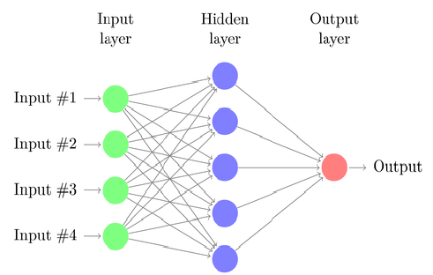
Figure 24:Typical model of a MLP Network
Input data in passed through the input layer with each node corresponding to a single value in the dataset. The values then pass through each hidden layer with the weights and biases applied until finally, in the context of this project, one output is given, Tremor/No Tremor along with a confidence value. In order for the neural network to be effective however, it needs to be trained with a given dataset. By providing training data that includes the expected output, the NN continues to adjust its weights and biases after each set of data and looking at the loss from the expected output. Through back propagation and an optimization method known as stochastic gradient descent the weights and biases are changed accordingly. In phase 2 the MLP model used is shown below:

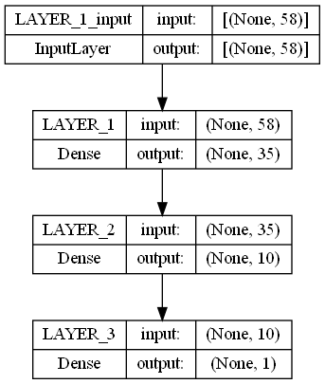
Figure 25: NiTech MLP model for phase 2
As can be seen in figure (22) the MLP model consists of an input layer that takes in 58 data points. These data point being used are in fact the output values of the FFT function in phase1. There consists of three hidden layers with 58, 35 and 10 nodes in that order before reaching an output that gives a value that can then be used to classify tremors or no-tremors. In order to train this network 700 datasets were recorded using the experimental setup with varying prevalent frequencies however sticking within the range of typical tremor frequencies. 70% of the dataset was used for training while 30% was used for evaluating/testing the network.

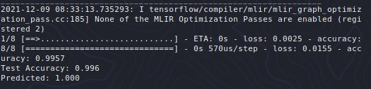
Figure 26: Test result after training NN
As can be seen in figure (23), the test result yielded a 99.6% accuracy in classifying tremors based on the test dataset, as such this level of accuracy is sufficient for the purposes of this project. Finally, the IMU was put back on the hand again and tested to see how the network would react to non-ideal situations.
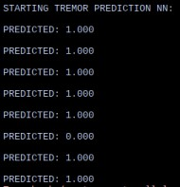
Figure 27:Testing NN prediction on hand
As it can be seen the predicted output displays the accurate value a majority of the time. In order to combat the outlier visible in figure (24) a moving average can be implemented for the output of the ANN. As such now it can be seen that the system detects tremors effectively, in ideal and unideal situations.

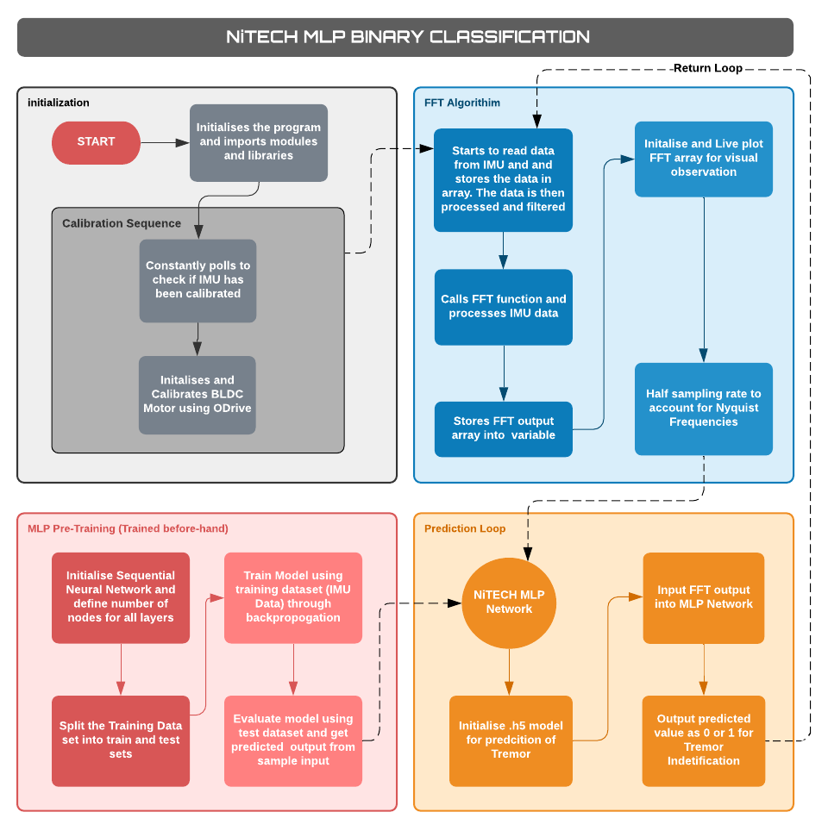
Figure 28: Final Code flow of NiTech Tremor Classification program

NN Learning Optimization and Verification
It is important to ensure that the designed MLP network is learning based on the given dataset along with understanding the efficiency of the network structure itself. One method for understanding how the neural network behaved was by looking at several different graphical outputs using TensorFlow’s built in visualization suite called Tensor board. Using this tool an educated inference could be made on the networks rate of learning, what layers contributed the most and where optimizations could be made to ‘prune’ away unneeded neurons or layers in the network.

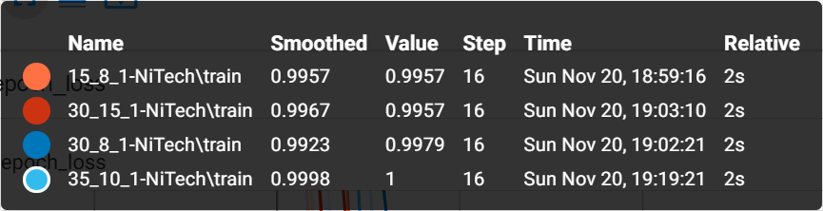
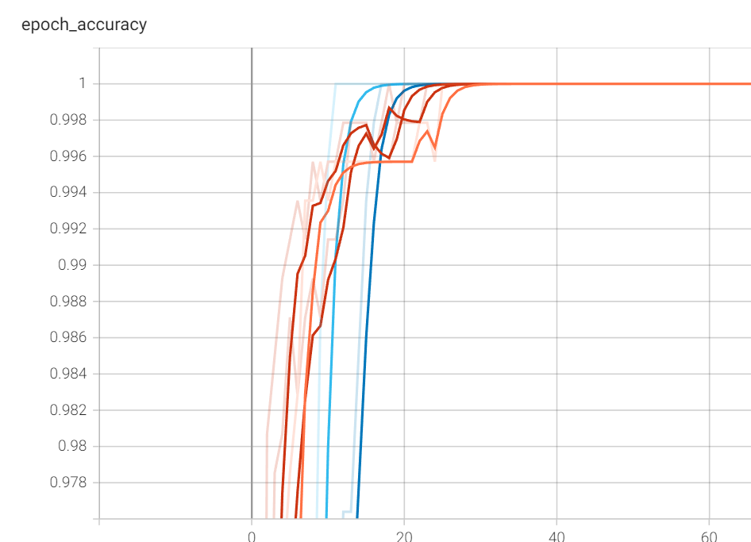
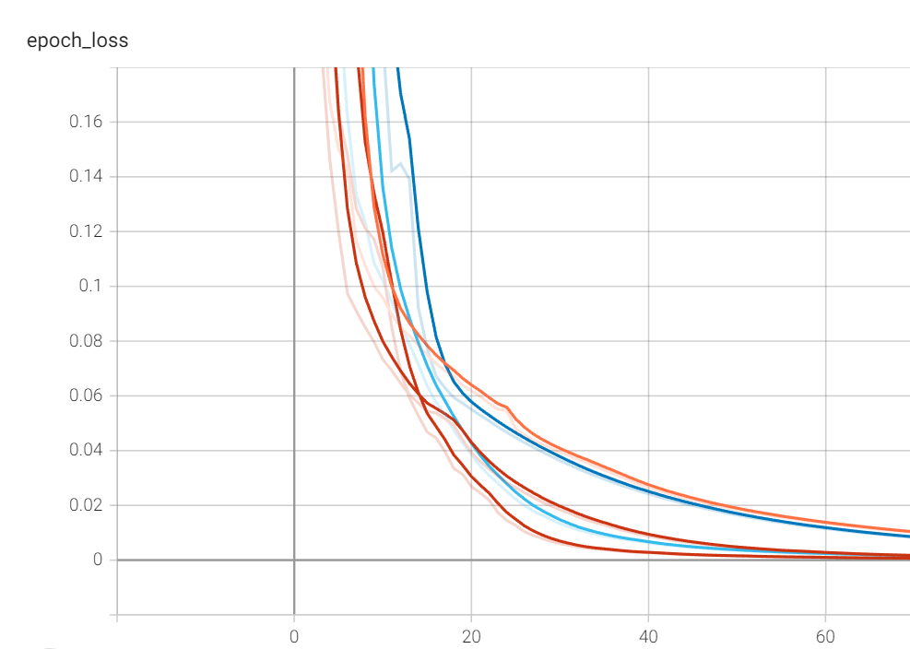
Figure 29: Graph of Accuracy and Loss at each training epoch
Figure 29 displays two graphs showing accuracy and loss comparisons between different network structures at each epoch step in the training run. The number of hidden layers were kept the same, however the number neurons at each layer were varied slightly. Of the 4 results it could be seen that the learning rate of speed was increased with higher number of neurons, With the best result being seen with the 35_10_1 structure network showing the fastest learning rate with an accuracy of 1 at epoch step 16.

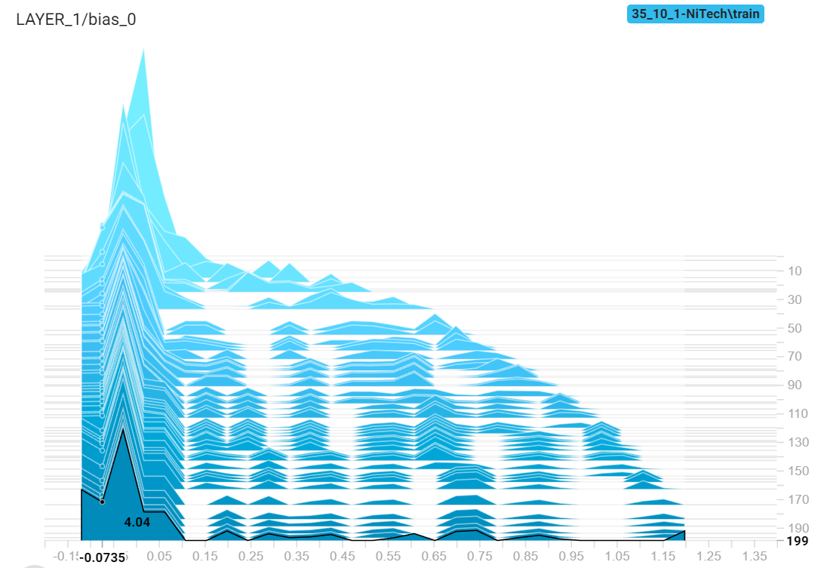
Figure 30: Visualization of bias distributions for layer 1
Looking at figure 30 it can be seen that in the first layer we see at epoch 1 the biases are all approximately 0, as represented by the high peak at 0 for epoch 1. However, as the training progresses, we see the distribution spread out to different values indicating that the network is learning.

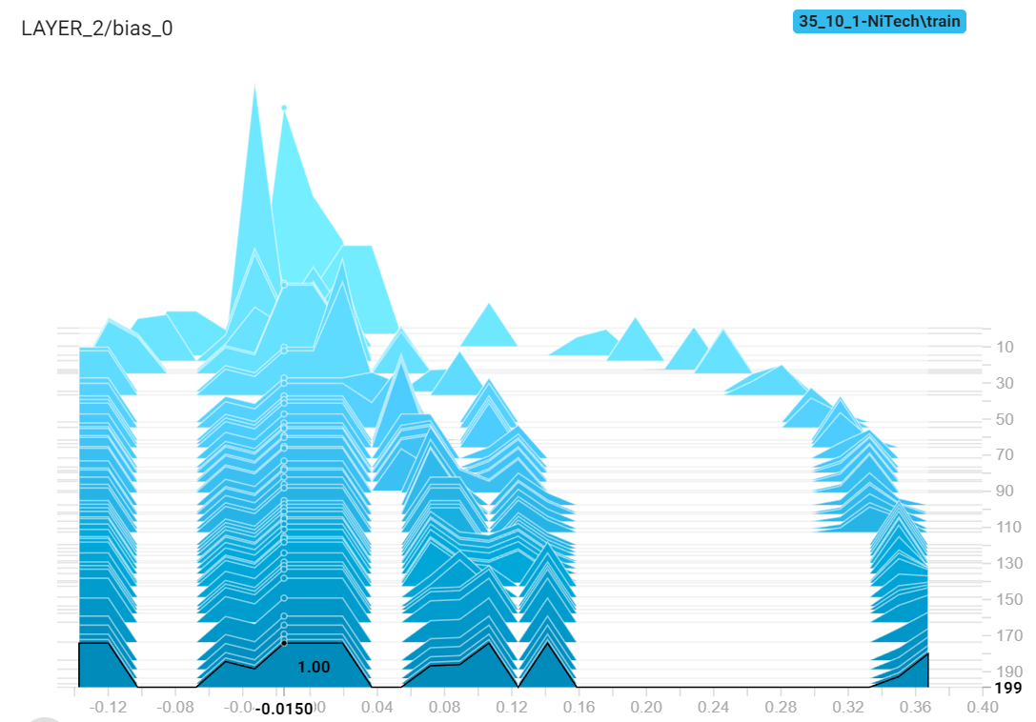
Figure 31: Visualization of bias distributions for layer 2
When observing figure 31 we see a more defined distribution at a quicker rate indicating that layer 2 is also learning at a good rate. Since both graphs do not show similar distributions from epoch 1 to epoch 200, it can be inferred that the network is learning. Some problems to account for when training the neural networks is overfitting of data. This occurs when the data used for training does not cover the wide array of possibilities that the neural network would encounter. To account for this it is best to use data retrieved from the hand to ensure the trained network can differentiate between tremor and non-tremors in practical applications and focus on the true aspects of data and achieve correct feature extraction.

Pruning of the existing network was not run as the network as it stands achieves the desired result and increases in neurons per layer have proved beneficial to training time. As such it will be more beneficial to see if addition of neurons and layers will prove to show better efficiency in learning

Phase 3

Physical Design Concepts
The final phase, phase 3 looked at the design and construction of the actuation method and the hand. Through the process of ohmic heating, Nitinol wires are able to be actuated. This is when current is passed through the wire by applying a voltage which results in the resistance of the wire heating the metal up ( this project use nitinol wire with transformation temp of 60°C). By doing this you transform the metal from a low temperature to a high temperature phase or in more accurate terms the metal changes from a martensite to austenite phase allowing it to bend back to the shape that it “remembers in the austenite phase. By using this mechanic one is able to apply loads and actuate by engaging the nitinol wire when need be. In the case of this project, the nitinol wire aims to provide rigidity and stability to an arm experiencing tremors by applying a resistive load to the hand. This in turn will mitigate the effects of tremors while helping patients to carry out day to day tasks that may not be possible otherwise. In order to best utilize this mechanic several concepts were thought of:
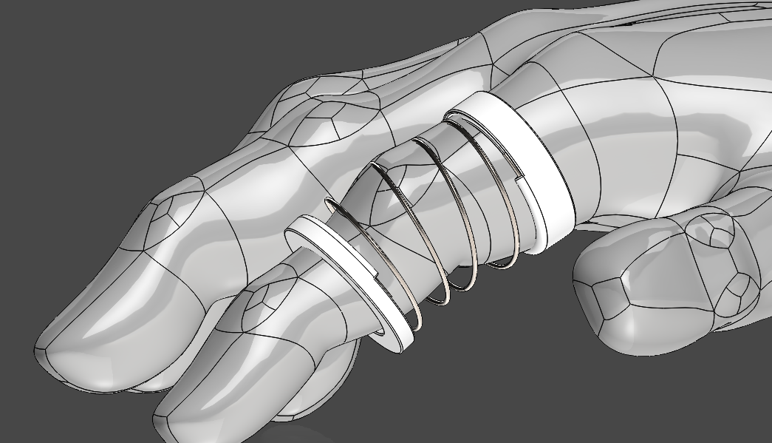
Figure 32:Concept one involves nitinol in a spring form
This concept works by providing an all-around spring like action that when not activated is malleable and flexible, however upon activation, provides a resistive force to the finger, resulting in more rigidity and support. The brace around the finger provide uniform loading and support. The problem with this solution involves the fact that the form factor is not at all compact and will get bulkier as more fingers are added on. As such this design is not viable for use in the NiTech glove.
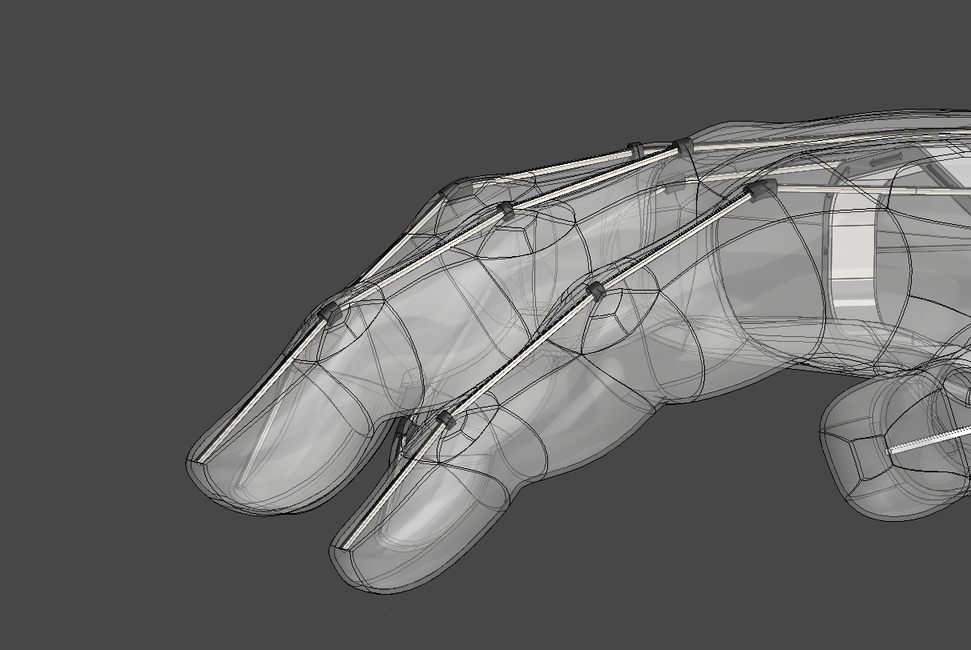
Figure 33: Concept 2 with straight wires across
Concept two is one that has nitinol wires running down the length of the fingers while being embedded in a glove. This concept has the advantage of being a very minimal form factor with the wires being the only intrusion. However, the design lack s the leverage to provide enough resistive force along and across the whole hand. Areas of the hand will be held under load while other areas are not, resulting in discomfort and lack of effect.

With the advantages of both in mind, concept three was designed. Although still not fully finished, concept three focuses on using a brace across the bottom half of the palm. This results in a good support and a uniform resistive load. The brace at the wrist also provide ample leverage as such the nitinol will be more effective in mitigating tremors. The brace termed the “NiTech Cage” is easy to manufacture and produce do to its size and compatibility 3D printing, whereas concept 2 required intricate small pars as linkages.

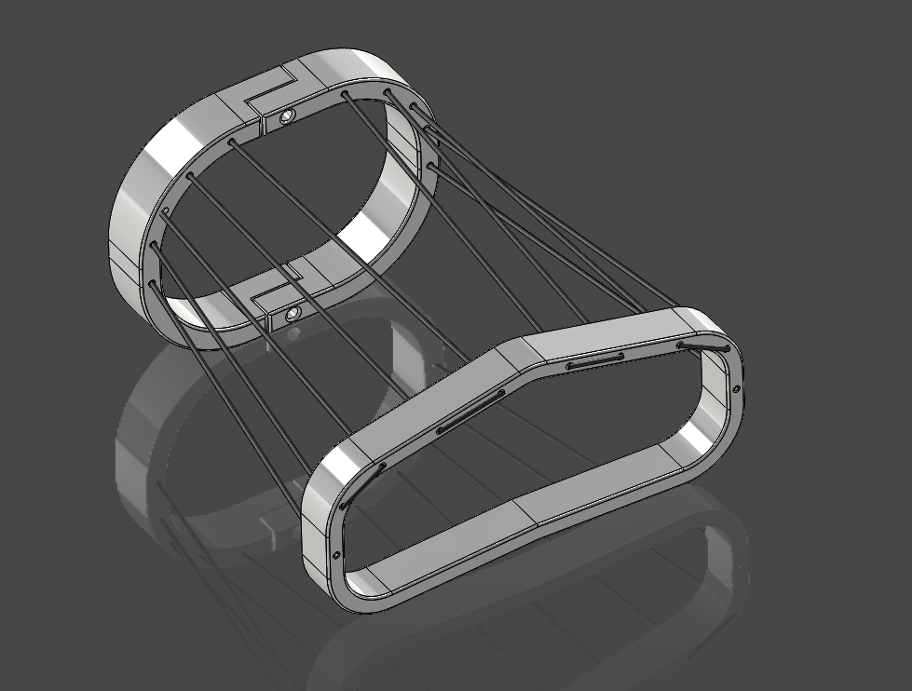
Figure 34:Concept 3 - NiTech Cage
As such the current prototype is of this form. A heat resistant glove will also be placed between the frame and the hand to ensure no discomfort from the contact of hand to plastic, while at the same time all components will be sowed securely onto the glove to minimize the need for more hard material as supports or fixtures.

Hardware and Electronics
In order to ensure the MLP Network is run as a portable unit, a Raspberry Pi Zero W will be used with the trained MLP NN running on it. An IMU BNO055 will also be attached to center most topside of the hand. To ensure the maximum effect when reading the Euler angles from all axes. And finally, a Pi Pico is to be used along with a LiPo Battery and a MOSFET in order to control temperature of nitinol wire during activation by providing a PWM signal. The addition of a thermocouple allows for a closed loop control of the nitinol temperature, with implementations such as PID and LQR allowing for proper monitoring. In the previous iterations of the design, without proper control the nitinol wire reaches temperatures that are not appropriate for user comfort and safety. By regulating the temperature, steady heating of the nitinol wire ensures better longevity for the material after each transformation cycle.
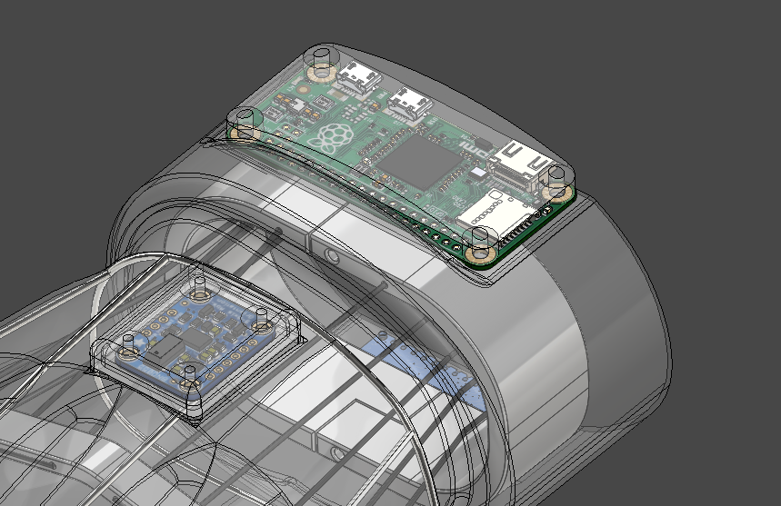
Figure 35:Component placements

Future Developments & Reflection

Software
In terms of software, the general system for identifying tremors works as planned. The holistic nature of the MLP Network helps to provide a more flexible system that can react to and classify tremors in a wider range of frequencies and under non ideal situations more accurately, while at the same time having an accuracy of 99.6%.

Some improvements that can be made on the existing MLP is a better optimized number of neurons and layers. Currently the structure of the network is based on trial and error, however there is scope to implement brute force solutions through code. Optimization algorithms can be implemented that take epoch accuracy, loss, and training speed as a cost function in order to identify a suitable structure for the given application. Overfitting of data is another crucial aspect that needs to be addressed, and in the later phases mitigating this will help improve compatibility for all users. Currently the data retrieved is based on experimental data and as such the network is shaped based on an ideal experimental condition. This leads to the network running feature extraction based on data not representative of actual use case scenarios, leading to a flawed perception of data, and as a such bad performance in real life applications

Another feature that needs to be added in future development of the software is the ability to learn while on the user’s hand. By providing a button to press when a tremor occurs and having a MySQL database to store datasets that were recorded. The user will be able to press the button during a period of tremor allowing the glove to record the dataset at that instance, store it in a SQL database and then train itself later on in the day with the accumulated dataset. A second button will also be provided to signal that a classification is wrong if by some chance the nitinol activated while no tremor was occurring.

Physical Design
The current physical design has potential for more research into the best way to place nitinol wire around the hand to best mitigate the effects of tremors. By doing this the glove will be able to remove unnecessary wirings which can lead to a more natural and comfortable feeling glove. Secondly Better linkages have to be designed between the heat resistant glove and the plastic frame. To ensure any leverage that the nitinol and frame provide is not lost due to slipping between the two materials. Finally, the wrist brace must attach itself onto the wrist more effectively to ensure that a sufficient anchor point is reached.

One of the key disadvantages of nitinol is the effect of thermal hysteresis in transformation from the two stages. Transition from the martensitic to austenitic stage occurs above the transformation temperature. However, the transition from austenitic to martensitic stage happens well below the transition temperature. Currently with this design transformation rate can be controlled by the input of current from joule heating, however the cooing rate of the metal is slow and as such its take a little longer to ‘deactivate’ the nitinol than it does to activate it. Currently this should not pose a problem for users as tremors develop and leave slowly during day-to-day life, however a solution to cool down the nitinol at a faster rate will ensure greater control over the whole system and provides avenues for quick action stabilization that falls beyond the scope of this project. There’s exists currently to solutions for active cooling:
- Water cooling using a pump
- Air flow using a fan
Water cooling provide rapid cooling of the metal. However, this is at the cost of a smaller form factor and portability due to the required addition of a water pump. Fan cooled systems also exist that provide moving air over the fans and work relatively well (not as effective as water) however, this too poses problems such as sound which are not desirable for the users and moves away from the goal of a minimal form factor. Due to these reasons the addition of active cooling was avoided until better portable solutions can arise that fit the goal of this project.

Safety
In order to ensure the safety of the user, several key aspects must be looked at:
- Dangers associated with LiPo Batteries
- Regulation of Nitinol Heat in the case of malfunction
- Electrocution due to exposed wires.
LiPo batteries pose a significant risk to users due to their volatile nature. Proper procedures have to be followed to ensure that the battery is drained and charged properly, along with requirement of secure storage. As such alternatives to LiPo such as LiFe provide better safety and durability to variable conditions.

To ensure that the wire does not heat up during operation and exceed safer temperatures, Operation and activation of the wire will only commence when a thermocouple is present to regulate the temperature. In the case of a faulty thermocouple, the absence of expected data or indication of faulty data from te thermocouple will warrant a full cut off of power to the wire. An emergency stop switch will also be placed in case of further problems to complete cut off power to the system. Finally, to ensure that electrocution does not occur, material will separate the glove from the hand to make sure that the skin does not come in contact with any live wires. The current and voltage used in this project is relatively low at 5V and 2Amps as such extreme danger is not present. However, to ensure discomfort and minor shocks do not exist this safety precaution must be met.

Conclusion
In conclusion throughout this project three main factors had to come into play in order for the NiTech glove to be a success. The system used for identifying tremors had to be effective yet smart enough that it can isolate tremors from everyday activities. And through this project that is believed to have been achieved. The system needs a minimal form factor actuation method that has no moving parts, and as can be seen the nitinol actuation method serves as a good solution. Finally, the design has to accommodate all necessary components and be comfortable to wear. Here the requirements are yet to be refined, however proof of concept has been achieved on the project and provides a road map for future research into the topics discussed in the Future developments section. Goals for a better designed NiTech Cage, Optimizations for the neural network and a portable, small solution for active cooling will ensure a better and more robust system that can react to, understand, and mitigate the non-linear behavior of tremors.

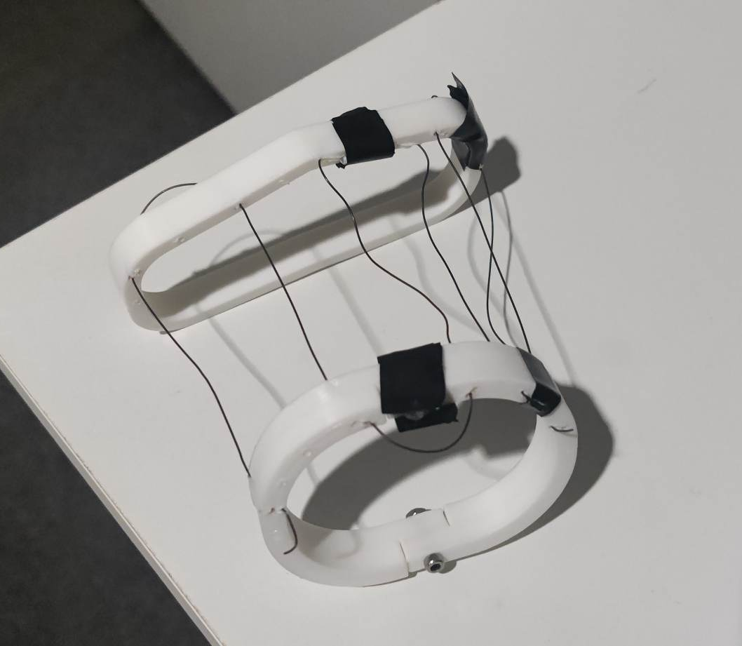
Figure 36: Final Prototype of the Design

References
1. What contributes to quality of life in patients with Parkinson's disease? Schrag, Anette, Jahanshahi, Marjan and Quinn, Niall. March 01, 2001, J Neurol Neurosurg Psychiatry.
2. Deep Brain Stimulation. Perlmutter, Joel S and Mink, Jonathan W. 2006, Neurosci.
3. The clinical approach to movement disorders. Abdo, Wilson F, et al. January 2010, Nature reviews | neurology.
4. The Pathophysiology of Essential Tremor and Parkinson's Disease. Rick, Helmich C, Toni, Ivan and Deuschl, Günther. July 27, 2013, NEUROIMAGING (DJ BROOKS).
5. Tremor. Saifee, Tabish A. 2019, British Medical Bulletin.
6. Time-frequency analysis of tremors. O'Suilleabhain, P E and Matsumoto, J Y.
7. Differentiating Essential Tremor and Parkinson’s Disease using a Wearable Sensor – A Pilot Study. Locatelli, P and Alimonti, D. 2017, ACADEMIA.
8. The pathophysiology of essential tremor and Parkinson's tremor. Helmich, R C, et al. Current neurology and neuroscience reports.
9. Etiology of Essential Tremor:Should We Be Searching for Environmental Causes? Louis, Elan D. 2001, Movement Disorders.
10. Etiology of Parkinson’s Disease. Huang, Zhigao, Fuente-Fernández, Raúl de la and Stoessl, A Jon. 2003.
11. Botulinum toxin treatment in tremors. Joseph Jankovic, MD. Essential Tremor.
12. Botulinum toxin for the treatment of tremor. Mittala, Shivam O, Lenka, Abhishek and Jankovicc, Joseph. Science Direct.
13. Beta-blocker therapy for tremor in Parkinson's disease. Crosby, N J, Deane, K and Clarke, C E. 2010, WILEY.
14. Beta-blockers for hypertension (Review). Wiysonge, C S, et al. 2017, Cochrane Library.
15. Okun, Michael S and Zeilman, Pamela R. Deep Brain Stimulation: Practical Guide for Patients and Families.
16. Complications of Deep Brain Stimulation: A Collective Review. Chan, D T, et al. 2009, ELSEVIER.
17. Damper Glove for Hand Tremor. Lazaro, G H and Ramos, M C. 2018, Semantic Scholar.
18. De Panisse, Paul. TREMOR STABILISATION APPARATUS AND METHODS. October 7, 2020.
19. Mechanical vibration does not systematically reduce the tremor in essential tremor patients. Lora-Millán, J S, et al. 2019, Scientific Reports.
20. A review of shape memory alloy research, applications and opportunities. Jani, Jaronie Mohd , et al. 2014, Materials & Design.
21. An overview of nitinol medical applications. Duerig, T, Pelton, A and Stöckel, D. 1999, ELSVIER.
22. MODELLING AND TEMPERATURE CONTROL OF SHAPE MEMORY ALLOYS WITH FAST ELECTRICAL HEATING. Ramiro Velázquez, Ramiro and Pissaloux, Edwige E. 2012, International Journal of Mechanics and Control.
23. Improving the Speed of Shape Memory Alloy Actuators by Faster Electrical Heating. Featherstone, Roy and Teh, Yee Harn. 2004, Experimental Robotics IX.
24. Fatigue of Nitinol: The state-of-theart and ongoing challenges. Mitchell, M R. 2015, ACADEMIA.
25. Shape-Memory Polymers. Lendlein, Andreas and Kelch, Steffen. 2002, Shape Memory Effect.
26. Magnetic Shape Memory Polymers with Integrated Multifunctional Shape Manipulation. Ze, Q, et al. Wiley.
27. Review of electro-active shape-memory polymer composite. Liu, Yanju, et al. 2009, ELSEVIER.
28. Rheosense. VISCOSITY OF NEWTONIAN AND NON-NEWTONIAN FLUIDS. [Online] https://www.rheosense.com/applications/viscosity/newtonian-non-newtonian#:~:text=Fluids%20are%20shear%20thinning%20if,include%20ketchup%2C%20paints%20and%20blood..
29. Flow Enhancement of Shear-Thinning Liquids under Longitudinal Vibrations. Jurg Ellenberger, Rajamani Krishna. 2017, Chemie Ingenieur.
30. Vibrational "ow of non-Newtonian "uids. Deshpande, N S and Barigou, M. 2001, Chemicl Engineering Science.
31. IMU Sensor-Based Hand Gesture Recognition for. Kim, Minwoo, et al. 2019, Sensors.
32. An approach for identifying gait events using wavelet denoising. Soangra, Rahul, Lockhart, Thurmon E and Van de Berge, Nathalie. 2011, PROCEEDINGS of the HUMAN FACTORS and ERGONOMICS SOCIETY.
33. On numerical study of Parkinson tremor. ∗Annalakshmi Harikrishna, Dennis Effah Osei, Magdalena Weronika Kami´nska, Sarangam Majumdar. 2016.
34. Cogging Torque Ripple Minimization. Matthew Piccoli, Mark Yin.

Appendix

MLP Code Output
